56W Frameless BLDC Motor
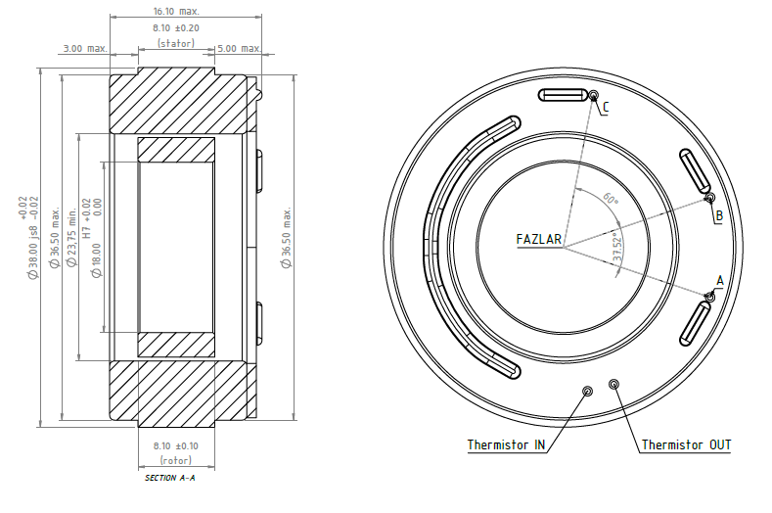
Basic Motor Parameters
Rated Power | W | 56
Rated Speed | rpm | 5200
Rated Torque | Nm | 0.102
Rated Current | A | 5.7
Rated Voltage | V | 12
No-Load Speed | rpm | 6900
Max. Efficiency | % | 90
Electrical Parameters
Number of Phases |  | 3
Number of Poles |  | 14
Torque Constant (KT) | Nm/A | 0.0179
Back EMF Constant (KE) | Vs/rad | 0.0166
Terminal Resistance Phase to Phase (±%10) | mΩ | 250
Terminal Inductance Phase to Phase (±%30) | mH | 100
Thermal Data
Ambient Temperature | °C | -40...+85
Max. Winding Temperature | °C | +155
Physical Parameters
Outer Diameter | mm | 38
Shaft Diameter | mm | N/A
Max. Lenght | mm | 16.1
Weight | gr | 11
Motor Connection
U | A
V | B
W | C
Sensor Connection
N/A | N/A
Connector Articles
Power | N/A
Signal | N/A

